Now you have the basic hardware tools, its time to setup the software environment.The main software you will need are:
- AVR Studio – A GUI IDE for AVR(www.atmel.com, http://www.atmel.com/dyn/resources/prod_documents/AVRStudio4.13SP2.exe)
- WinAVR – a free C compiler for AVRs (http://winavr.sourceforge.net/download.html)
- PonyProg – Serial Device Programmer (www.lancos.com)
After downloading them install them in your computer. It is better to install WinAVR in root of a drive like c:\winavr or d:\winavr. Also please install WinAVR first then AVR Studio, this will let AVR Studio detect the compiler. Now you are ready to write you first microcontroller program !!! In this tutorial, you will learn the basic steps required for any microcontrollers based project. We will write a basic “hello world” project, which is a simple LED blinker in MCU empire to demonstrate these basic steps.

Step I Entering and compiling code.
Start “AVR Studio” from Start Menu->All programs->Atmel AVR Tools-> AVR Studio 4 You will be presented with a Project wizard as shown below.
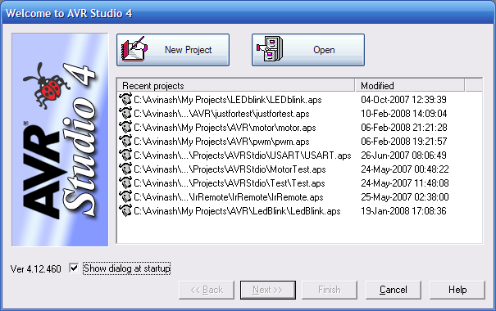

Fig - AVR Studio Project Wizard

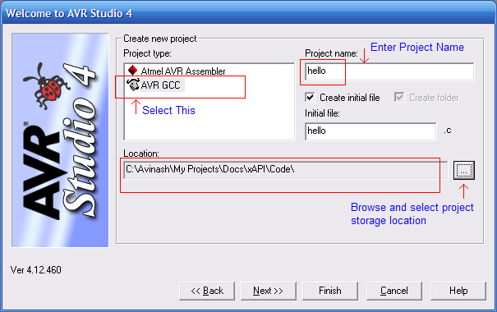

Fig - Project Details
Select AVR GCC in Project type then enter a suitable project name say “hello” and select a location in you hard disk. Then click next. Make sure that “Create initial file” and “Create folder” option is checked.
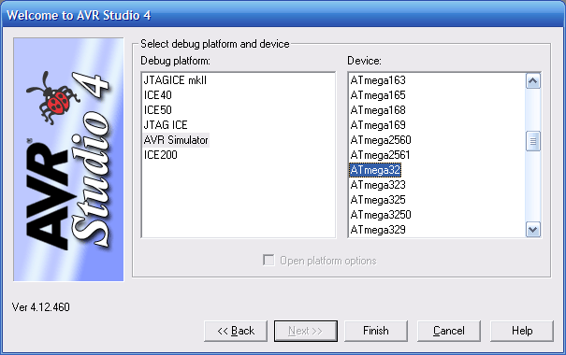

Fig - Device Selection
In this dialog box select AVR Simulator in “Debug Platform” list and select the AVR MCU depending on the type of MCU installed on your development board, in Device list. Click finish. After that you will be presented with an Integrated Development Environment-IDE. As shown below.
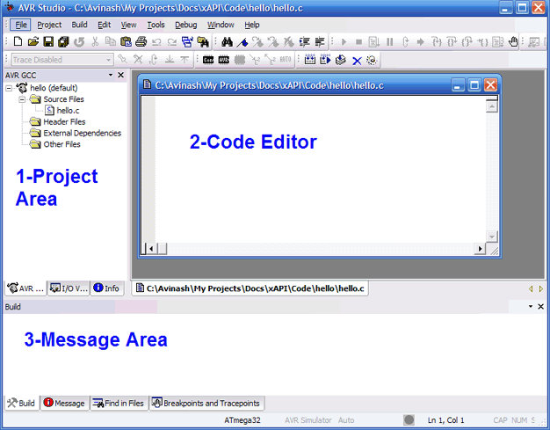

Fig - AVR Studio main window
This IDE will help you in editing, modifying, and compile source program. After a project is compiled it gives you a “.hex” file ready to burn to your MCU. The main parts of the window are
- Project Area – displays all the files source and header in the current project. You can add and remove files by the context menu of different groups like “source file” , “header files” etc. Double click a file to open it in the editor.
- Code Editor – Here you enter and edit the files.
- Message Area – Here AVR Studio will show errors and warning generated by compile when it tries to compile a source file.
Now copy past or type the following code in the code editor.

#include <avr/io.h>
#include <util/delay.h>

void Wait()
{
uint8_t i=0;
for(;i<23;i++)
_delay_loop_2(0);
}

void main()
{
//Set PORTC0 as output

DDRC=0b00000001;

while(1)
{
//Set PC0=High(+5v)
PORTC|=0b00000001;
Wait();

//Set PC0=Low(GND)
PORTC&=0b11111110;
Wait();
}
}

If you don't understand the program don't worry, the next tutorial will teach you how to setup and use general purpose IO ports in AVR.
Go to Project->Configuration Options to bring the Project option dialog.
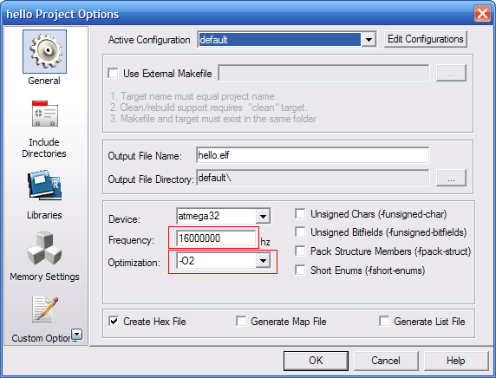

Fig - Setting CPU frequency and compiler optimization
Enter the CPU frequency. If you are using AVR Board enter 16Mhz i.e. 16000000. In addition, select optimization as -O2. Click ok. Now you have entered the code now time to compile and build the project. Press F7 or select Build->Build or click the toolbar button for Build active configuration. If the code is error free AVR studio will show you the following message.
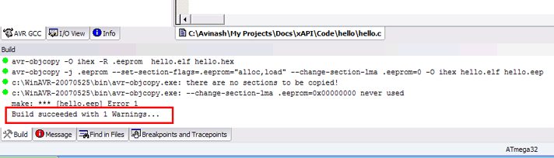

Fig - Message
“Build succeed with 1 warning. Don’t worry about the one warning it is due to the fact that ANSI standard suggest that return type of main() must be one, but for MCU platform there is no environment or operating system that will receive this returned value. So return type of main() is void. Now you have successfully compiled you first project, what you have got after compilation and build is “.hex file”. You can find it in a folder named “default” in you project folder. It has same name as you project, in this case “hello.hex”
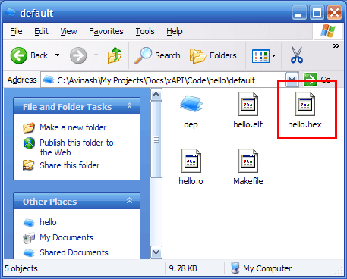

Fig - Finding "hello.hex" file

Step II Programming the MCU with “hello.hex”.
Now its time to burn this hex file to your MCU. To know how to burn the hex file to you MCU refer to you programmers manual. Detailed procedure is given in “programmer” folder in its support CD.

Programming Using PonyProg.
This is the programmer we made in the previous tutorial. Its use is simple. Start Ponyprog, you will get a screen similar to this.
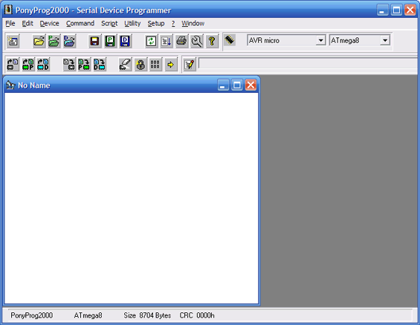

Fig - Ponyprog main window.
First, you need some setup. Go to menu setup->interface setup and make setting like this.
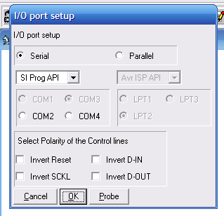

Fig - Ponyprog Setup
Select the serial port in which your programmer is connected. Beware there may be more that 1 available com port showing there and usually only one is available outside the PC the rest are internal and may be connected to your modem. So make sure you have selected a port that is connected to your programmer and not to your modem. Next, go to set up->calibration. Now you are done. Connect the programmer you have made to you PCs serial port and connect its ISP connector to the target you have made. Switch on the target. The software is self explanatory with easy to use GUI in the top tool bar there is a selection for type of chip you want to program. Select “AVR Micro” and select the type of Micro( like ATmega8) in box next to it.
- Select the hex file you want to program using the File->Open Program(FLASH) file.
- Command->Erase.
- Command->Write Flash
- Command->Verify Program(FLASH)
- If every thing is correct, your MCU is programmed successfully.
- Disconnect programmer from the Target and switch it off.

Step III Electrical Connections.
This is a very simple project you don’t need any complicated connection.You may be using any of our development boards like xBoard™, xBoard™ MINI or simpler xCards™. You just need to figure out where is the MCU ports (which is programmed to blink LED, in this case PORT C’S 0TH BIT) connector on the board. They are clearly marked in the boards. After finding it, connect the LED as follows to the MCU port .Or you can make your own target boards as explained in previous tutorials. I am not showing all the connection here because I have already shown in previous tutorials.
The VCC (5v) required is also available in the board and marked as “spare 5V” or something like that. After all connections connect power supply (make sure the polarity is correct) to the board and switch on. The power indicator LED of board should glow and the LED connected to the MCU’s port should blink on and off. Now you can relax and enjoy than light blinking with all that modern sophisticated technology behind it and you first dedicated embedded program doing all the magic.
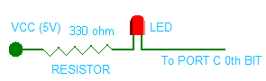

Fig - Connecting a LED.
Now go on with your imagination tweak the program, modify delay and switching logic to get interesting patterns blinking. The limit is your imagination.

